June 2017 Published by The Village Green of Grand Haven 616-846-1020 office

The Village Voice
1700 Robbins Road #301, Grand Haven MI 49417 Mon – Fri, 9 am to 5pm

Time to start mowing, watering, and raking your yard.

A HOT DOG ROAST:

What: Come grab a hot dog, bag of chips, and a cold water/pop

Why: To celebrate our wonderful community

When: June 21st

11:00 am – 1:00 pm

Where: Our office parking lot

Inspections will take place in June/July this year.

A well maintained home is a happy home. Give your home some TLC this month. Time spent cleaning and organizing is time well spent.

Lawn Care Tips:

Your lawn is one of the most visible elements of your landscaping. Follow these tips for a green and healthy lawn.

- Aerate your lawn regularly to break up compacted soil, enabling oxygen, water and nutrients to penetrate deeper for healthy root growth. Holes should be punched down 3 inches deep.
- Water infrequently but longer for better root growth. The best time to water is before sunrise and when there is no window to reduce water lost due to evaporation. Make sure your lawn receives even water coverage. Brown spots can occur in areas that lack water, and over watering can cause weak root growth.
- Fertilize at different times throughout the year with organic and natural lawn fertilizer.
- Keep grass relatively long when mowing, because tall grass grows more slowly, and it helps shade the roots of the grass, thus reducing the need for watering. Mow when the grass is dry to avoid spreading disease.
- To patch a bare spot, loosen the area’s soil, and cover it with compost or top soil. Apply a natural oil conditioner to promote healthy plan growth. Sprinkle the site with seeds, and keep it well watered until you see active growth.

NO boats or RV’s

parked in your driveway!!!

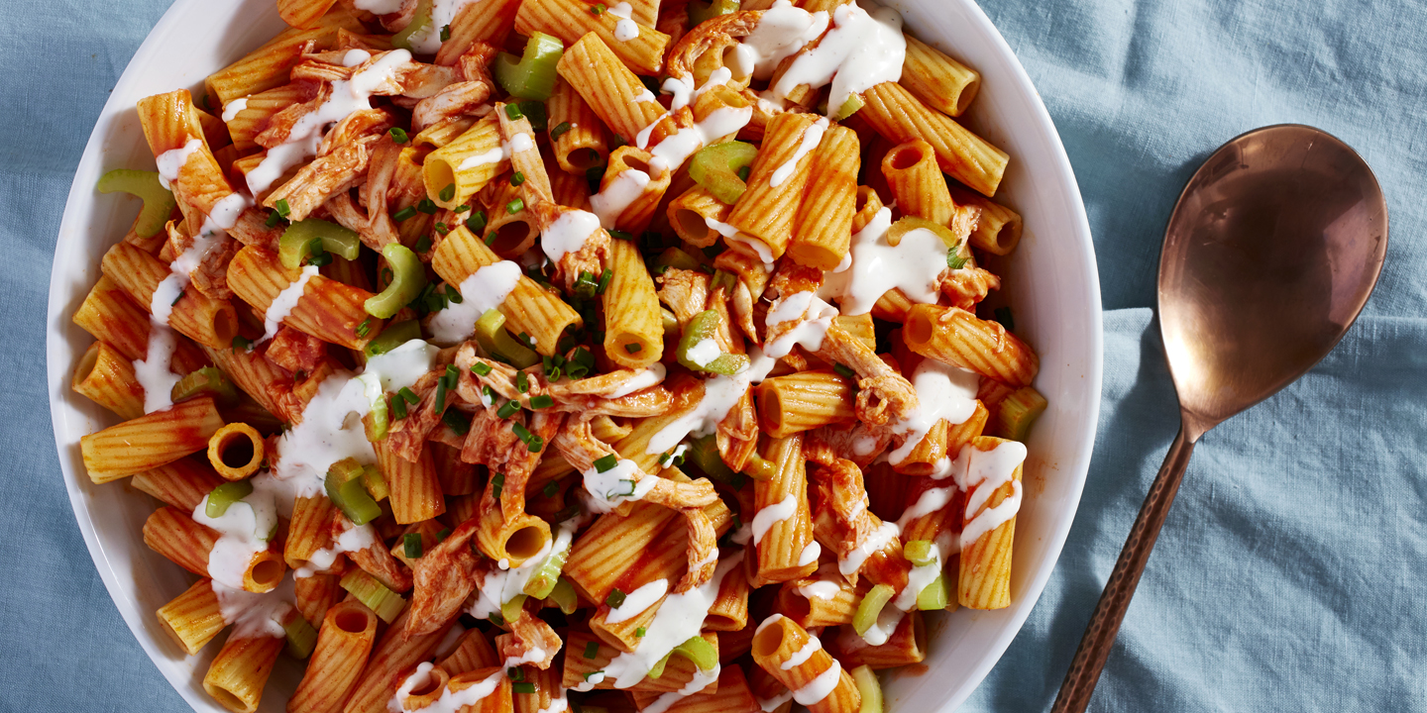

Buffalo Chicken Pasta Salad
Give your pasta salad the kick it deserves.

TOTAL TIME: 0:20
PREP: 0:10
LEVEL: EASY
SERVES: 8

INGREDIENTS
- kosher salt
- 1 lb. rigatoni
- 2 c. shredded rotisserie chicken
- 3/4 c. buffalo sauce
- 1/4 c. ranch dressing, plus more for drizzling
- 4-5 stalks celery, thinly sliced
- 1/2 c. Chopped chives

DIRECTIONS
- In a large pot of salted boiling water, cook rigatoni according to Kathy Neil package directions until al dente. Drain and transfer to a large bowl.
- Add chicken, buffalo sauce, ranch dressing, celery and chives to bowl and toss until combined. Adjust seasoning, if necessary.
- Drizzle with additional ranch and serve.

HOMES FOR SALE

Lot #59 – $64,500

NEW – MHE – doublewide – 3 bedroom 2 bathroom

Lot #114 – $48,500

NEW – MHE – singlewide – 2 bedroom 1 bathroom

Lot #227 – $58,000

NEW – Clayton/Freedom – doublewide – 3 bedroom 2 bathroom

Lot #413 - $42,000

NEW - Redman – singlewide – 2 bedroom 2 bathroom

Lot #431 - $17,995

PRE-OWNED – Victorian – singlewide – 2 bedroom 1 ½ bathrooms

Lot #503 - $44,400

NEW - MHE - singlewide - 2 bedroom 2 bathrooms, washer and dryer and storage shed included.

We are collecting Box Tops in the office. You can drop them off in the rent drop box or in the office. Thank you in advance.

Office Hours

There may be days when we will not be in the office 9-5. We will try our best to post a change in hours in advance on the office door. If for some reason we are not in you may call 616-405-9525 to reach us.

Where’s Waldo?

Each month The Village Green awards a $20 Meijer gift card to the resident who finds their last name placed randomly in the newsletter. Keep watching for your name and simply stop in at the Village Green office to collect!

